




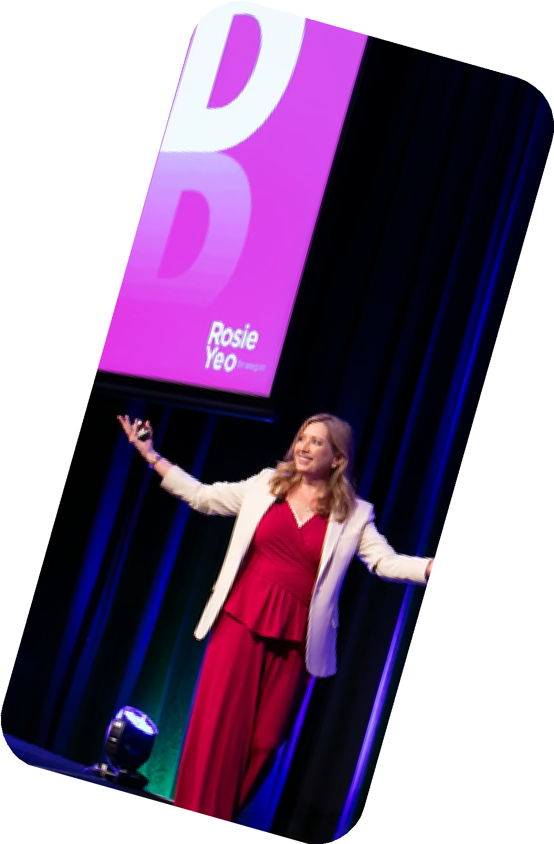


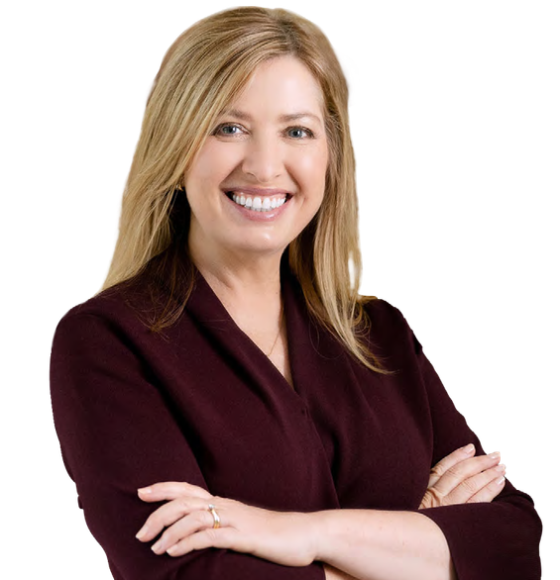






STRATEGIC MC & EXPERT FACILITATOR
Turning conversations into insight, connection and action.
Rosie Yeo combines the skills of an MC, facilitator and strategist to help conferences do more than share information. She connects ideas, surfaces key insights and creates momentum that extends beyond the event.

She unlocked how we think, work, and lead together.
FCM MEETINGS & EVENTS

CLICK HERE

to see Rosie speak

Services:
Conference MC & Moderator Roundtable Facilitation Strategic Planning

Ideal for:
Multi-speaker and panel conferences Leadership and strategy-focused events Programs where clear outcomes are critical

Why work with Rosie:
Creates meaningful conversations between audiences, speakers and panellists
Brings clarity to complex topics and competing perspectives Connects themes and ideas across the event
Turns discussion into practical next steps
Balances precise pacing with genuine audience engagement

