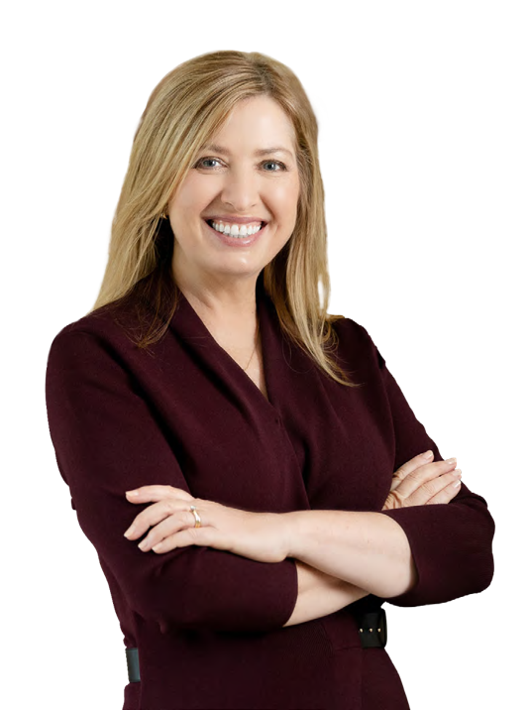

**Expert Facilitator | MC**



**Rosie Yeo**

MBA, BA(Hons), GAICD, CSP

# A warm, quick-witted and engaging facilitator, Rosie delivers high energy, intelligent facilitation for conferences and events. She inspires thought-provoking conversations with insight, curiosity, and humour.

**CONFERENCE/EVENTS MC**

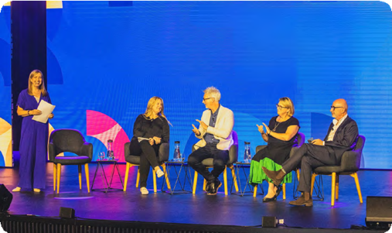

# When your conference or event involves big ideas and important debates, you need a professional facilitator and expert communicator to bring the best out of every conversation.

# Rosie has MC’d conferences, webinars and panel sessions for clients including Australian Business Events Association, businessNBN, Australian Logistics Council, and Tourism Australia. She engages participants in thought-provoking conversations, and translates complex ideas into accessible and relevant takeaways.

# For events, preparation is essential. Rosie will work with you to understand your event purpose, content and scripting, audience and contributors.

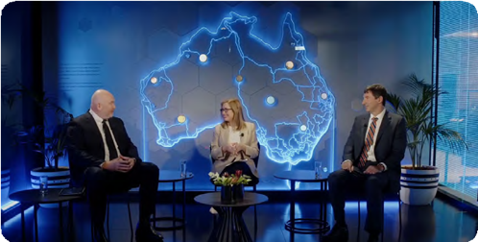

**STRATEGIC PLANNING**

**PANELS AND POLICY ROUNDTABLES**

Rosie manages challenging issues and diverse opinions with insight, curiosity and warmth. Her preparation and ability to master commercial and public policy perspectives set her apart.

**[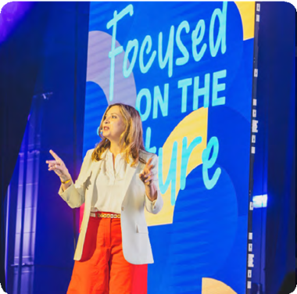](https://vimeo.com/1052196898?share=copy&t=0)**

# Rosie leads more strategy discussions in a year than most leaders want to attend in their lifetime. Her simple, powerful strategic planning processes will surface fresh ideas and reach powerful consensus. She works with Boards and Executives across sectors, including Sandoz, Mortgage Choice, Prime Capital, Infrastructure Australia, Tourism Australia, and Financial Advice Association of Australia, helping them set bolder ambitions and map smart pathways to bring them to life.



[**2 MINUTE VIDEO**](https://vimeo.com/1052196898?share=copy&t=0)

**PRAISE FROM CLIENTS**

Australian Business Events Association

Bristol-Myers Squibb

*“an absolute professional - warm, engaging, and always thoroughly prepared”*

*“a master of creating a safe and fruitful environment for open dialogue”*

# *“warm, incisive and engaging”*

Prime Financial Group

# *“she was the magic dust across our plenary sessions”*

ICC Sydney

**ROSIE YEO Strategist | Facilitator | Author**