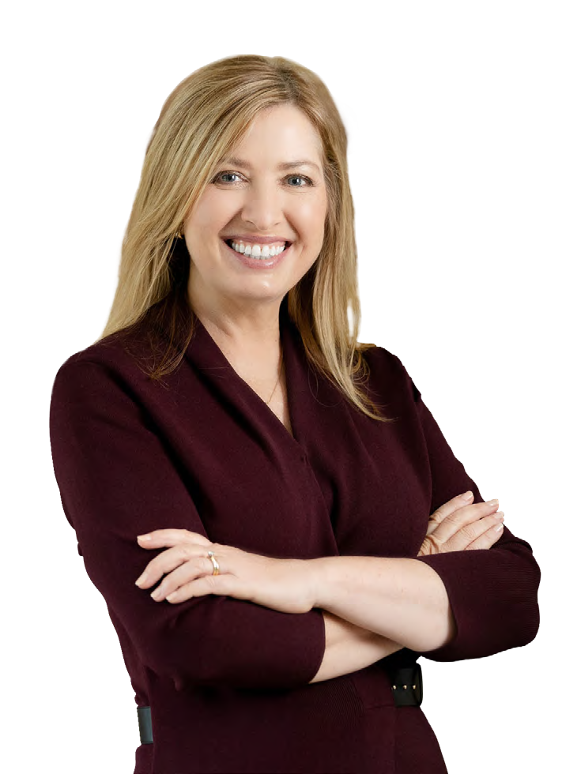

Go for BOLD!

**MBA, BA (Hons), GAICD, CSP**

Strategist, Facilitator, Author

ABOUT ROSIE YEO

**Summary bio**

# 

From pharmaceuticals and finance to aviation and infrastructure, Rosie leads more strategy discussions in a year than most leaders want to attend in their lifetime.

Rosie's 25 years' experience as a strategic adviser and facilitator inspired her to write "Go for Bold: How to create powerful strategy in uncertain times", a practical and inspiring guide for leaders on how to harness creativity and confidence to map the best pathways to success.

A warm, quick-witted and entertaining speaker and facilitator, Rosie challenges business leaders and their teams to set bolder ambitions and focus on results. She makes strategy simple, relatable, and compelling.

**MC INTRO: ROSIE YEO**

“Our next speaker is someone who makes strategy feel surprisingly human - and even a little bit fun. Rosie Yeo is a renowned strategy advisor, speaker, and author who helps leaders think bigger, and deliver. Her superpower is cutting through complexity to help people get clear, get confident, and get moving - without the corporate jargon or 200-page PowerPoint decks.

From Uluru to Abu Dhabi, Rosie has worked with boards, executive teams, and industry groups across Australia and around the world - and today she’s here to challenge us to reframe our future and take our next big leaps.”

**Long bio**

Strategist and expert facilitator Rosie Yeo helps thousands of executives, boards and business owners ditch the jargon, set higher ambitions and prioritise action.

As a board director and corporate affairs adviser, Rosie hated feeling trapped in unproductive, uninspiring planning sessions. She wanted to transform the way organisations design and implement their big plans.

From pharmaceuticals and finance to aviation and infrastructure, Rosie now leads more strategy sessions in a year than most leaders want to attend in their lifetime. Her work on strategy and innovation with corporate, government, and non-profit organisations gives her unique insights and pragmatic solutions.

Rosie’s 25 years’ experience as a political adviser, corporate consultant and facilitator inspired her to write "Go for Bold: How to create powerful strategy in uncertain times". The book demystifies strategy, making it accessible and relatable.

A warm, quick-witted and entertaining speaker, Rosie challenges business leaders and their teams to set bolder ambitions and focus on results. She makes strategy simple, relatable, and compelling.

She is also a skilled facilitator/MC, adept at managing complex conversations and bringing insight, curiosity, and humour to conferences, workshops, and policy roundtables.

Rosie was awarded an MBA from the University of New South Wales. She is a graduate member of the Australian Institute of Company Directors and accredited as a Certified Speaking Professional by Professional Speakers Australia.



|  |  |
| --- | --- |
| Keynotes | Gallagher Australia  Mortgage Choice  Pepsico Thailand  Professional Conference Organisers of Australia  College Capital  Institute of Internal Auditors. |
| MC:  Conferences  and events | Australian Business Events Association  businessNBN  Australian Logistics Council  Tourism Australia |
| Consultations and roundtables | Bristol Myers Squibb  Office of the National Data Commissioner  Department of Infrastructure, Transport, Regional Development, Communications and the Arts. |
| Strategic planning | Sandoz  Mortgage Choice  Prime Capital  Infrastructure Australia  Finity  Financial Advice Association of Australia |

**Client examples**

**What clients say**

**Managing Director and Chairman, Prime Prime Financial Group**

# *"Rosie is warm, incisive and engaging… with excellent delivery, good humour, and a clear sense of purpose”*

# *“a master of creating a safe and fruitful environment for open dialogue”*

**CEO, International Convention Centre (ICC)**

**Sydney**

# *“Rosie makes the complicated, simple”*

**Global CEO, cievents**

**Managing Director Australia & New Zealand,**

**Bristol-Myers Squibb**

Rosietravels from

*"an absolute professional - warm,*

*engaging, and always*

*thoroughly prepared”*

See Rosie speak

Sydney, Australia

Air travel in Aust/NZ: Economy, Qantas preferred

Air travel rest of world: Business

[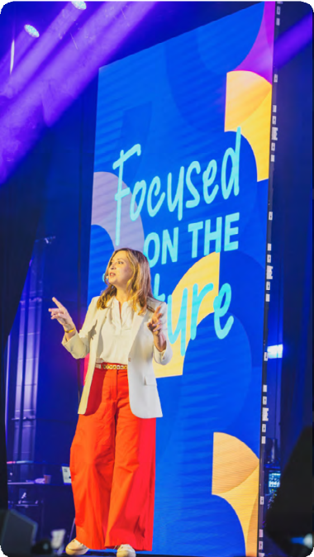](https://vimeo.com/1052196898?share=copy&t=0)

Sydney, Australia

Air travel in Aust/NZ: Economy, Qantas preferred

Air travel rest of world: Business

Rosietravels from

[](https://vimeo.com/1052196898?share=copy&t=0)

See Rosie speak

AV requests

* Lapel/headset microphone
* Data projector and screen, clicker
* Rosie can provide USB, slides in advance, or bring Mac laptop with connector