*A warm, quick-witted and entertaining speaker, Rosie challenges business leaders and their teams to skip the jargon and focus on results. She makes strategy relatable, meaningful and powerful.*

# K E Y N O T E S

**Go for BOLD!**

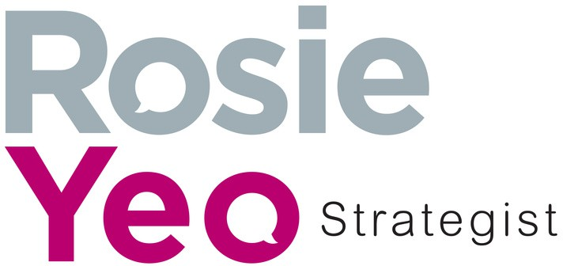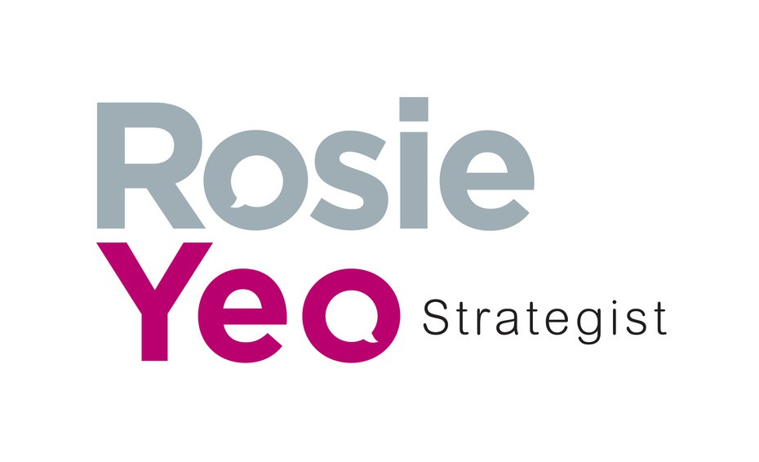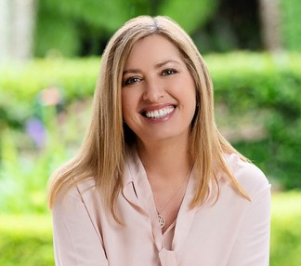

**Think bigger, and deliver with BOLD Strategy**

*Keynote Speaker and Expert Facilitator*

How ambitious are your plans - are they BOLD enough? And are they the right ones to succeed in a fast changing world?

**Leading beyond busy** A leader’s strategic mindset is built on three questions that will change the way you work, plan and lead.

**The Strategy Shortcut** A fast changing world demands we face the future with more creativity, more commitment and less jargon. Find your five step strategy for success.

## 

## E X P E R T F A C I L I T A T O R

**Strategic planning, policy roundtables, conferences, events** Rosie manages challenging issues and diverse opinions with insight,

curiosity, and humour. She will inspire thought-provoking, upbeat conversations and calls to action.

# R O S I E Y E O M B A , B A ( H o n s ) , G A I C D

From pharmaceuticals and finance to aviation and infrastructure, Rosie excels at leading strategic planning in challenging environments. Her experience as a corporate consultant, Board director and facilitator with leaders in business, government, and non-profit organisations gives her unique insights and pragmatic solutions to boardroom and business challenges.

## P R A I S E F R O M C L I E N T S

**“an absolute professional - warm, engaging, and always thoroughly prepared”**

Bristol-Myers Squibb

**“a master of creating a safe and fruitful environment for open dialogue”** Prime Financial Group

# WATCH ROSIE:

**“she was the magic dust across our plenary sessions**” Australian Business Events Association

**“you’ve inspired many of the team to step up and be Bold”** Gallagher Insurance

[**H E L P Y O U R P E O P L E G E T C L E A R , G E T C O N F I D E N T , A N D G E T M O V I N G .**](https://www.rosieyeo.com.au/app-landing-page) **B O O K R O S I E T O D A Y**

**[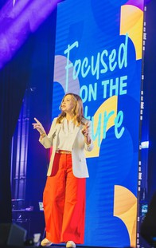](https://vimeo.com/1052196898?share=copy&t=0)2 MINUTE**

**VIDEO**