
ABOUT ROSIE YEO MBA, BA (Hons), GAICD, CSP
Strategist, Facilitator, Author

Go for BOLD!
Summary bio
Rosie Yeo is a strategist, speaker and expert facilitator who helps leaders and teams cut through jargon, think boldly and take decisive action.
With 25 years’ experience across politics, corporate affairs and strategy, Rosie has advised senior decision-makers at every level. A sought-after facilitator, she leads strategy discussions for corporate, association and public sector leaders in health, finance, aviation, infrastructure and tourism.
The author of “Go for Bold: How to create powerful strategy in uncertain times”, Rosie is a warm, quick-witted and entertaining speaker.
Her superpower is cutting through complexity to help people get clear, get confident, and get moving.

MC INTRO: ROSIE YEO
“Our next speaker is someone who makes strategy feel surprisingly human - and even a little bit fun. Rosie Yeo is a renowned strategy advisor, speaker, and author who helps leaders think bigger, and deliver. Her superpower is cutting through complexity to help people get clear, get confident, and get moving - without the corporate jargon or 200-page PowerPoint decks.
From Uluru to Abu Dhabi, Rosie has worked with boards, executive teams, and industry groups across Australia and around the world - and today she’s here to challenge us to reframe our future and take our next big leaps.”

Long bio
Rosie Yeo is a strategist and expert facilitator who helps thousands of executives, boards and business owners ditch the jargon, set higher ambitions and prioritise action.
Rosie began her career in politics, working at both Federal and State levels, becoming Senior Adviser to a former NSW Minister for Health. She went on to become Public Affairs Manager for the Australian Pharmaceutical Manufacturers Association before moving into corporate affairs consultancy, advising major companies and industry bodies.
After completing her MBA, Rosie was appointed to a national regulatory board for health practitioners, an experience that deepened her understanding of governance, decision-making, and how leaders navigate risk and reform.
Frustrated by unproductive, uninspiring planning sessions she witnessed as a board director and corporate adviser, Rosie set out to transform the way organisations design and implement their big plans.
From pharmaceuticals and finance to aviation and infrastructure, Rosie now leads more strategy sessions in a year than most leaders want to attend in their lifetime. Her work on strategy and innovation with corporate, government, and non-profit organisations gives her unique insights and pragmatic solutions.
Rosie’s 25 years’ experience as a political adviser, corporate consultant and facilitator inspired her to write "Go for Bold: How to create powerful strategy in uncertain times" which demystifies strategy, making it accessible, practical and engaging.
A warm, quick-witted and entertaining speaker, Rosie challenges leaders and their teams to set bolder ambitions and focus on results. She is also a skilled facilitator/MC, adept at managing complex conversations and bringing insight, curiosity, and humour to conferences, workshops, and policy roundtables.
Rosie holds an MBA from the University of New South Wales, is a graduate member of the Australian Institute of Company Directors, and is accredited as a Certified Speaking Professional by Professional Speakers Australia.


Keynotes | Gallagher Australia  Mortgage Choice  Pepsico Thailand  Professional Conference Organisers of Australia  College Capital  Institute of Internal Auditors.
MC:  Conferences  and events | Australian Business Events Association  businessNBN  Australian Logistics Council  Tourism Australia
Consultations and roundtables | Bristol Myers Squibb  Office of the National Data Commissioner  Department of Infrastructure, Transport, Regional Development, Communications and the Arts.
Strategic planning | Sandoz  Mortgage Choice  Prime Capital  Infrastructure Australia  Finity  Financial Advice Association of Australia
Client examples

What clients say

“Rosie was the magic dust across our plenary sessions”

CEO,
Australian Business Events Association

“The way Rosie engaged with our delegates was fantastic”

CEO, College Capital

“Rosie makes the complicated, simple”

Global CEO, cievents

“a master of creating a safe and fruitful environment for open dialogue”

Managing Director and Chairman,
Prime Financial Group

"Rosie is warm, incisive and engaging… with excellent delivery, good humour, and a clear sense of purpose”
CEO, International Convention Centre (ICC)
Sydney

"an absolute professional - warm,
engaging, and always
thoroughly prepared”
Managing Director Australia & New Zealand,
Bristol-Myers Squibb

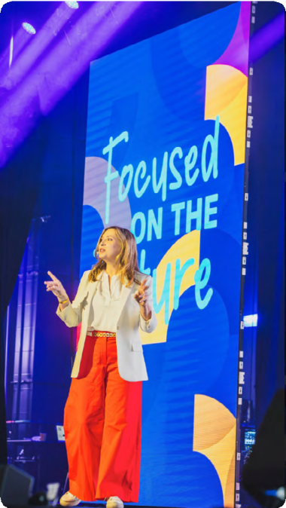

Sydney, Australia
Air travel in Aust/NZ: Economy, Qantas preferred
Air travel rest of world: Business
Rosie travels from

See Rosie speak
AV requests
- Lapel/headset microphone
- Data projector and screen, clicker
- Rosie can provide USB, slides in advance, or bring Mac laptop with connector

BOOK ROSIE TODAY

